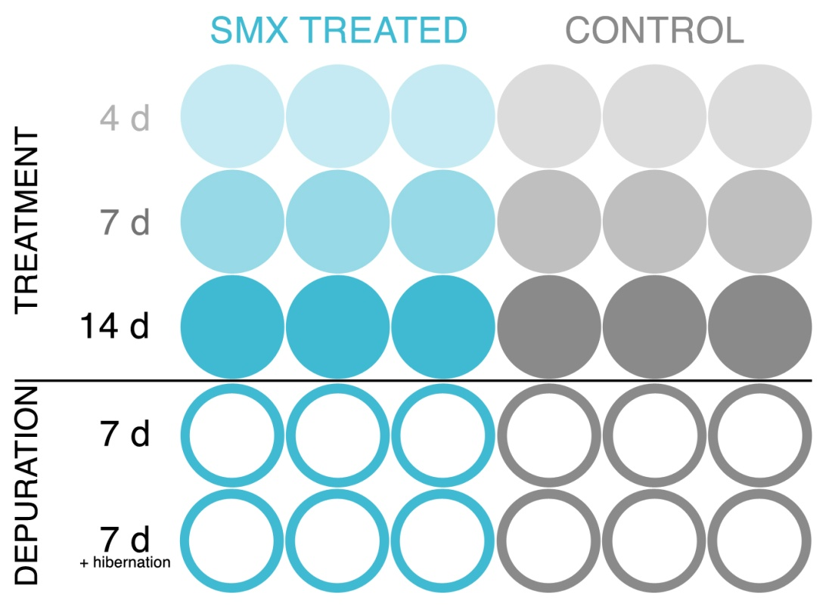
Figure 1. Experimental design of Stagnicola elodes laboratory study with snails undergoing exposure for 14 days (S4, S7, S14) followed by a 7-d depuration period (S7D) or 7-d hibernation period (S7F), plus control (C).

Figure 2. Mean ($±$SE) total abundances of sulfonamide antibiotic resistant genes standardized to abundances of 16S rRNA from laboratory jar water samples and analyzed using qPCR. C4 represents a control on day 4. S represents SMX treated jars. S4 (n=3), S7 (n=3), and S14 (n=3) represent the average abundance of ARGs in SMX treatment jars on day 4, day 7, and day 14. Snails from S14 treatment jars were transferred to untreated (no SMX) media in the seven day depuration (S7D) and hibernation jars (S7F). The average abundance of ARGs were then measured in the seven day depuration jar (S7D; n=3) and seven day hibernation jar (S7F; n=3).

Figure 3. Mean ($±$SD) concentration of sulfonamide antibiotic in water from laboratory treatment jar s from day 0 to 14 (S0, S1, S4, S7, S14; n=3) and control (n=1).

Figure 4. Average temperature (ºC) in each sample jar (mean$±$SD) over the 21 day study. Days 0 to 14 represent the temperature in sulfamethoxazole treatment jars (S), days 16 to 21 represent the temperature in depuration jars (D), plus control.

Figure 5. Average dissolved oxygen (mg/L) in each sample jar (mean$±$SD) over the 21 day study. Days 0 to 14 represent the dissolved oxygen in sulfamethoxazole treatment jars (S), days 16 to 21 represent the dissolved oxygen in depuration jars (D), plus control.

Figure 6. Average conductivity (µS) in each sample jar (mean$±$SD) over the 21 day study. Days 0 to 14 represent the conductivity in sulfamethoxazole treatment jars (S), days 16 to 21 represent the conductivity in depuration jars (D), plus control.

Figure 7. Average pH in each sample jar (mean$±$SD) over the 21 day study. Days 0 to 14 represent the pH in sulfamethoxazole treatment jars (S), days 16 to 21 represent the pH in depuration jars (D), plus control.

Table 1. Agarose recipe used for exposure in lab toxicity studies.
Substance |  | Amount
Control Jars | NaCl  Tryptone  Yeast Extract  Agarose  H₂O | 0.48 g  0.48 g  0.24 g  0.72 g  48 ml
SMX Jars | SMX | 6.4 mg

