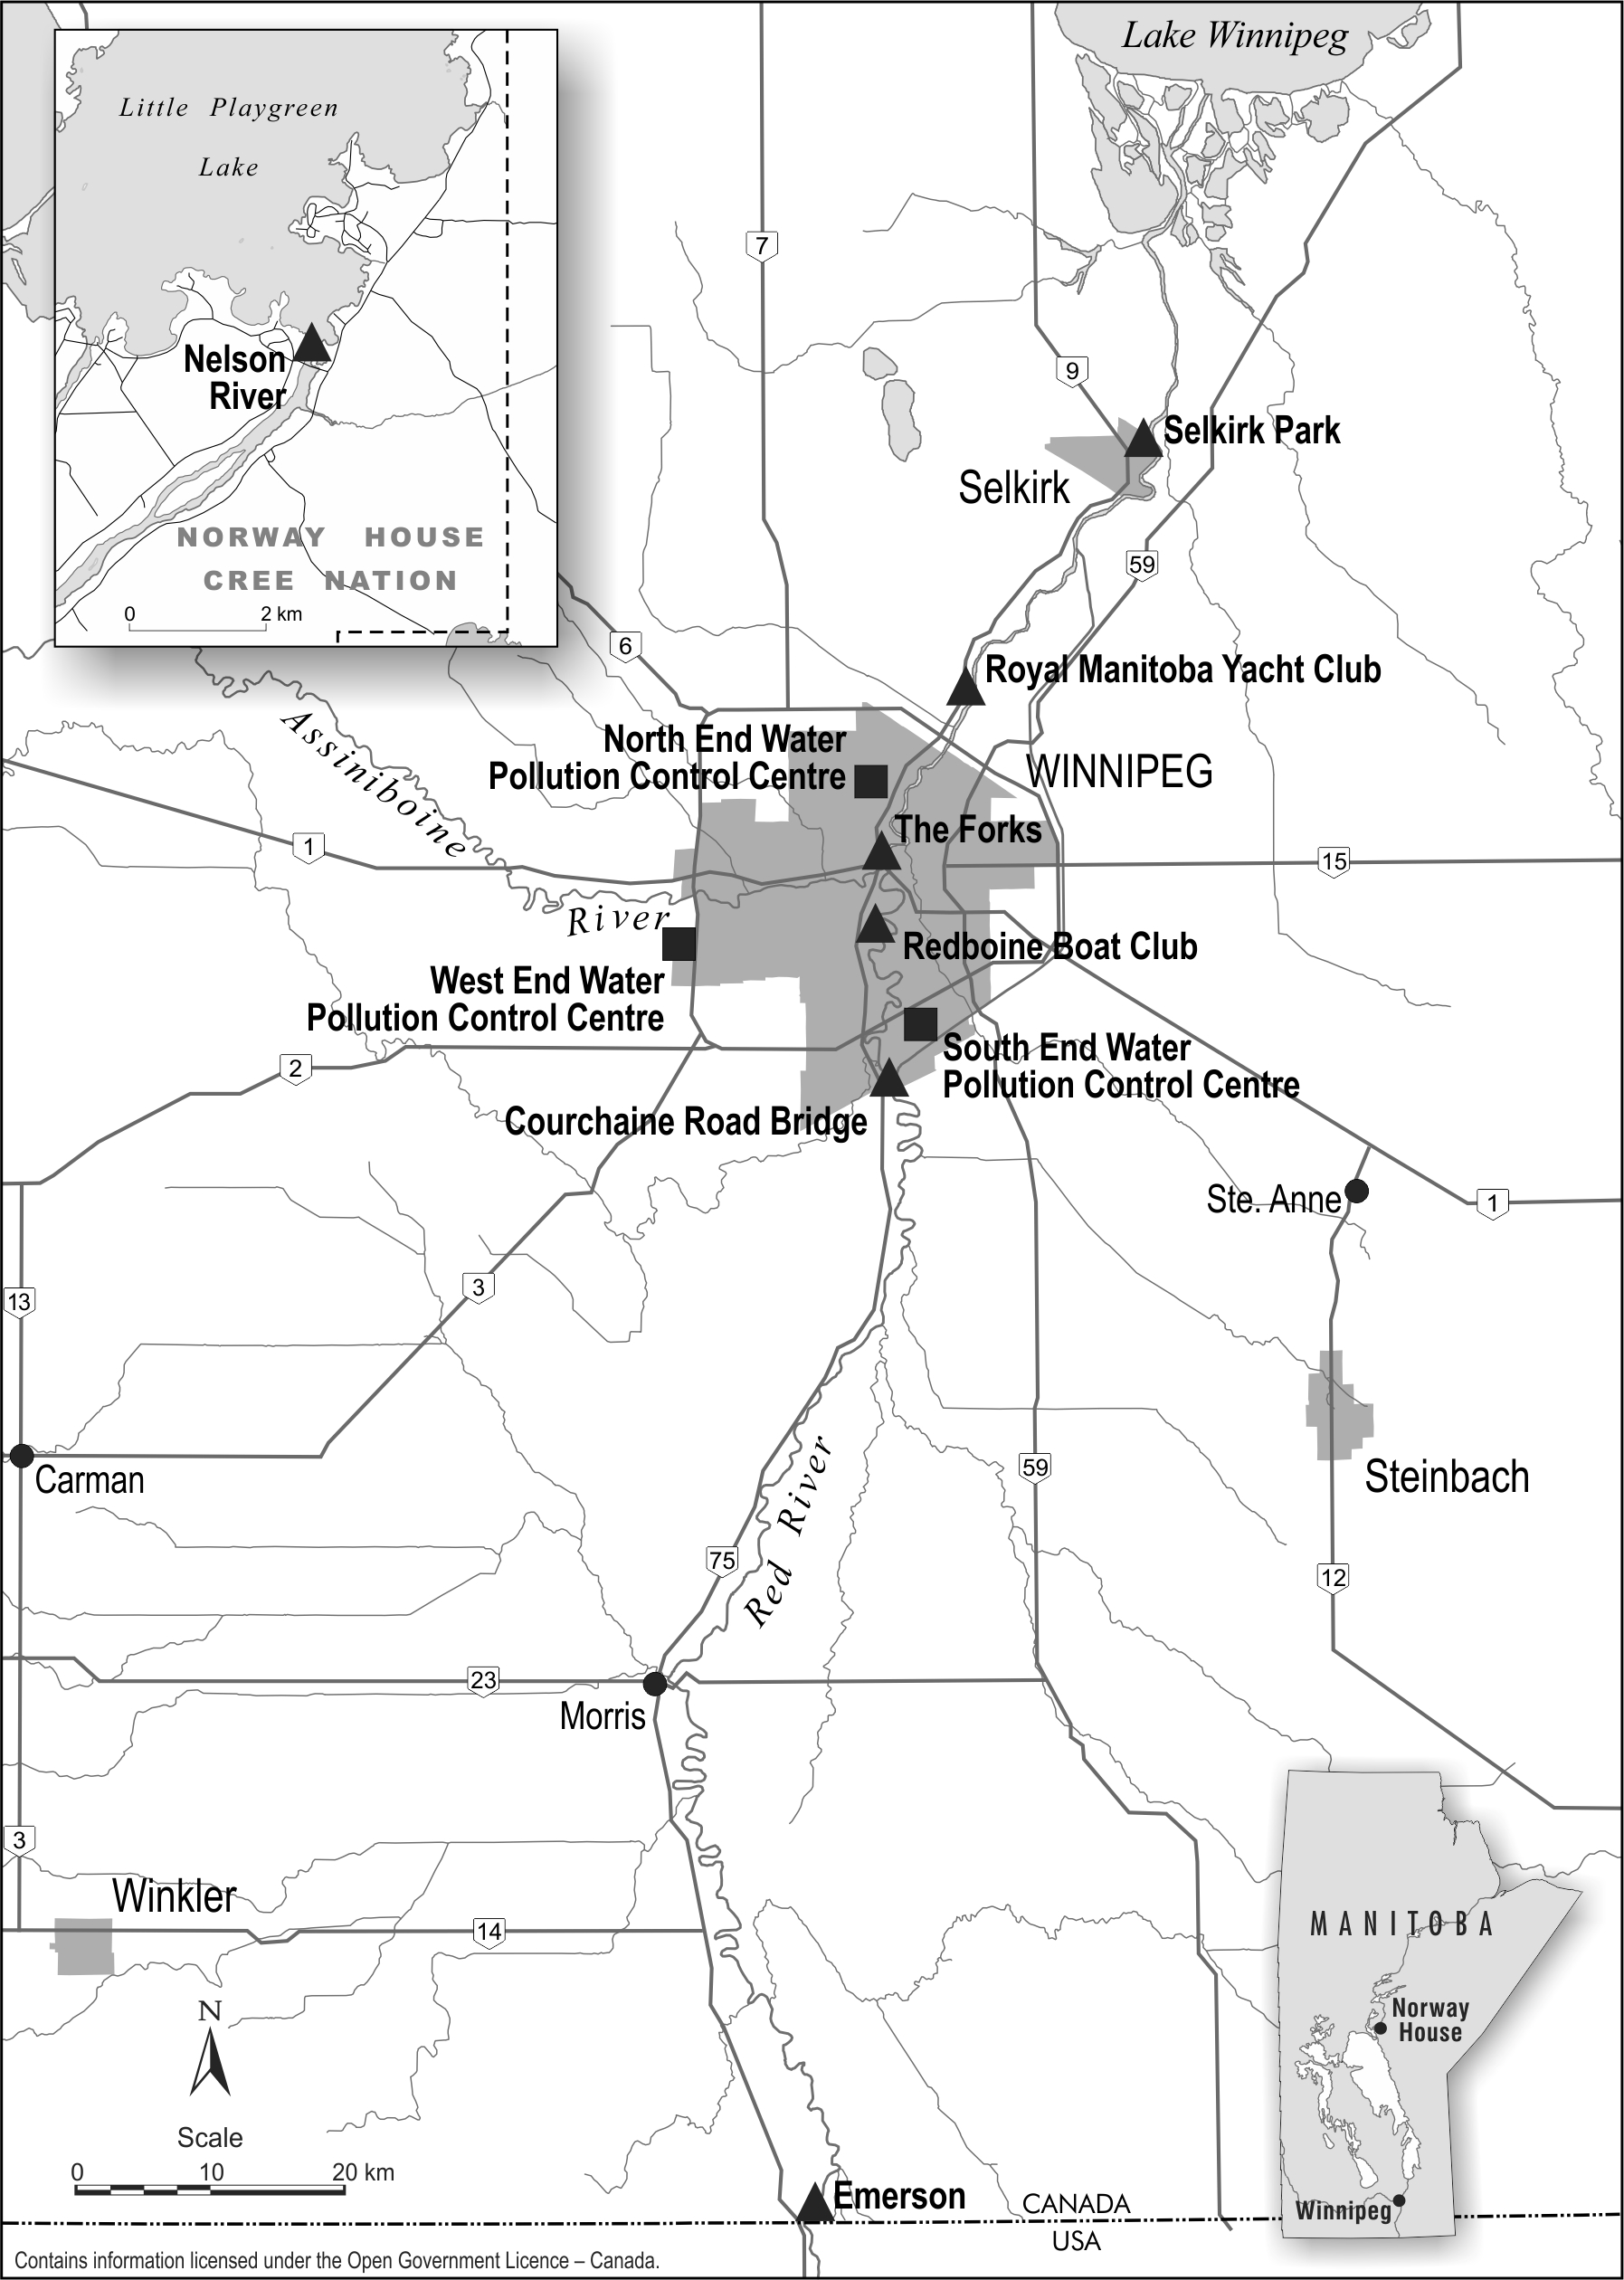

Figure 1. Map of surface water and fish (Selkirk Park) sample collection sites (triangles) and Winnipeg’s three wastewater treatment plants (squares): South End Water Pollution Control Centre, North End Water Pollution Control Centre, West End Water Pollution Control Centre. Emerson and Courchaine Road Bridge upstream of SEWPCC. Redboine Boat Club downstream of SEWPCC. RMYC downstream of NEWPCC. Forks downstream of WEWPCC.

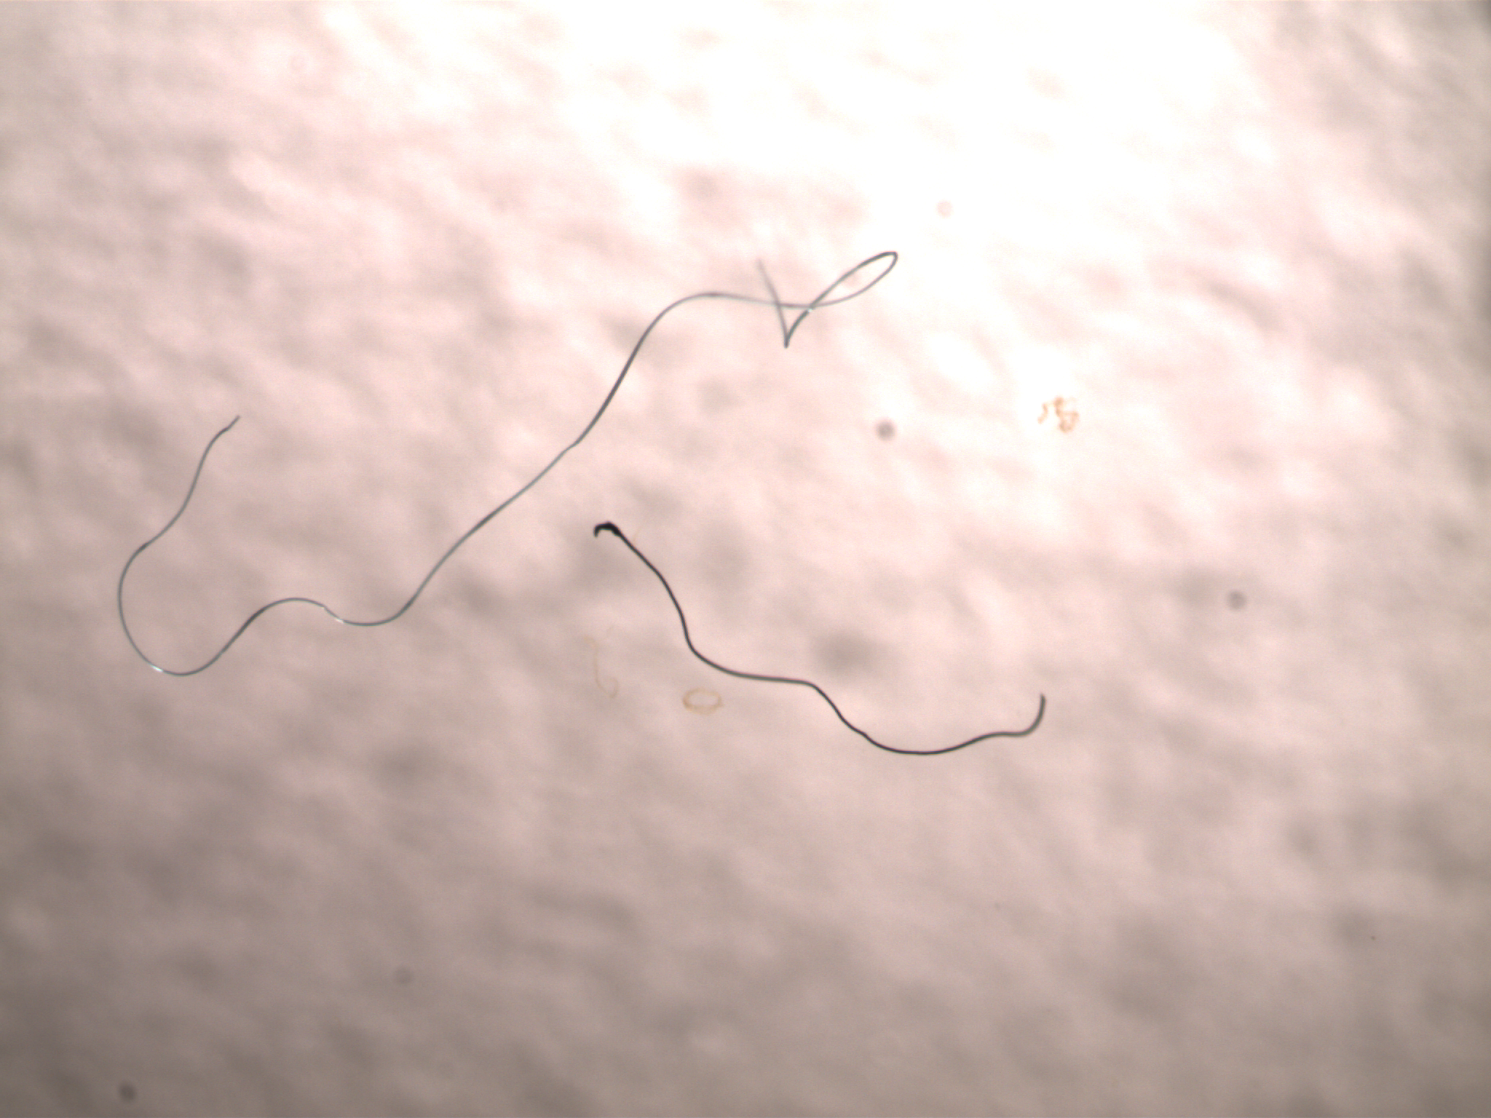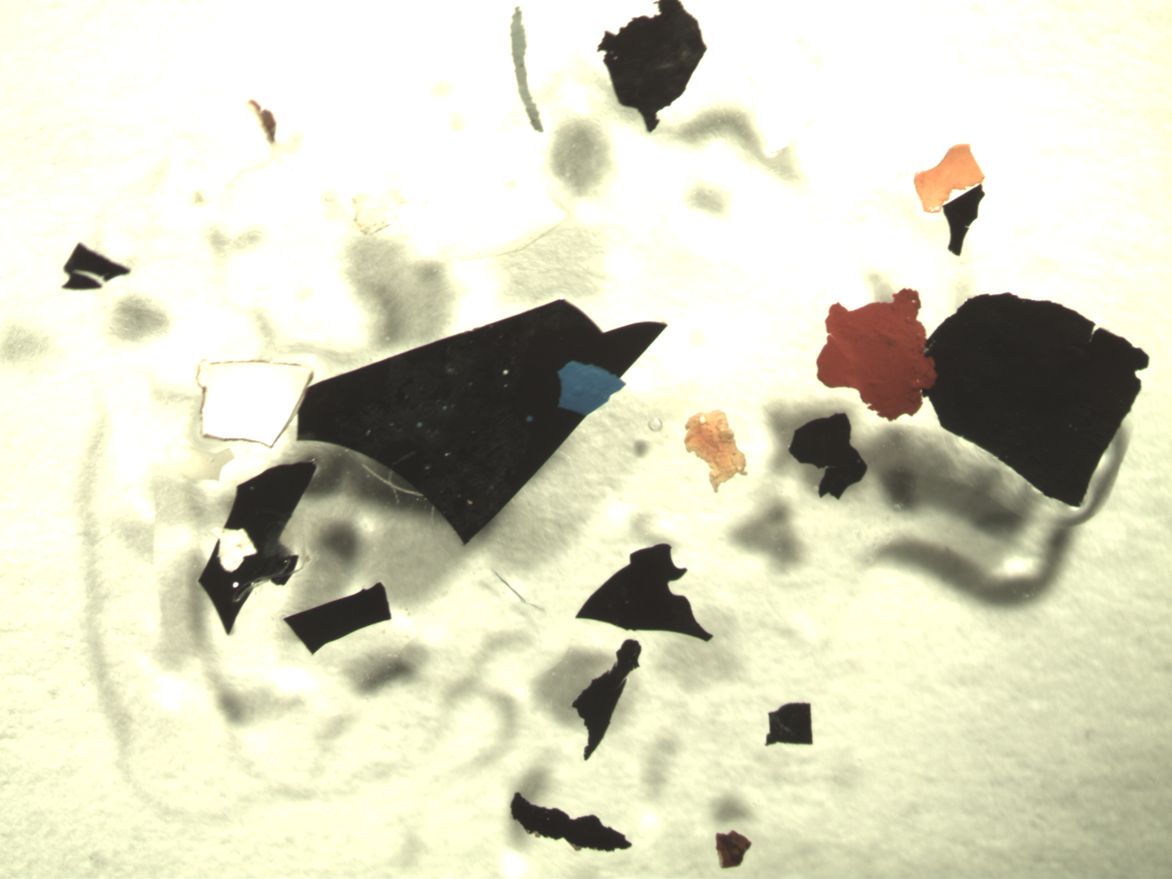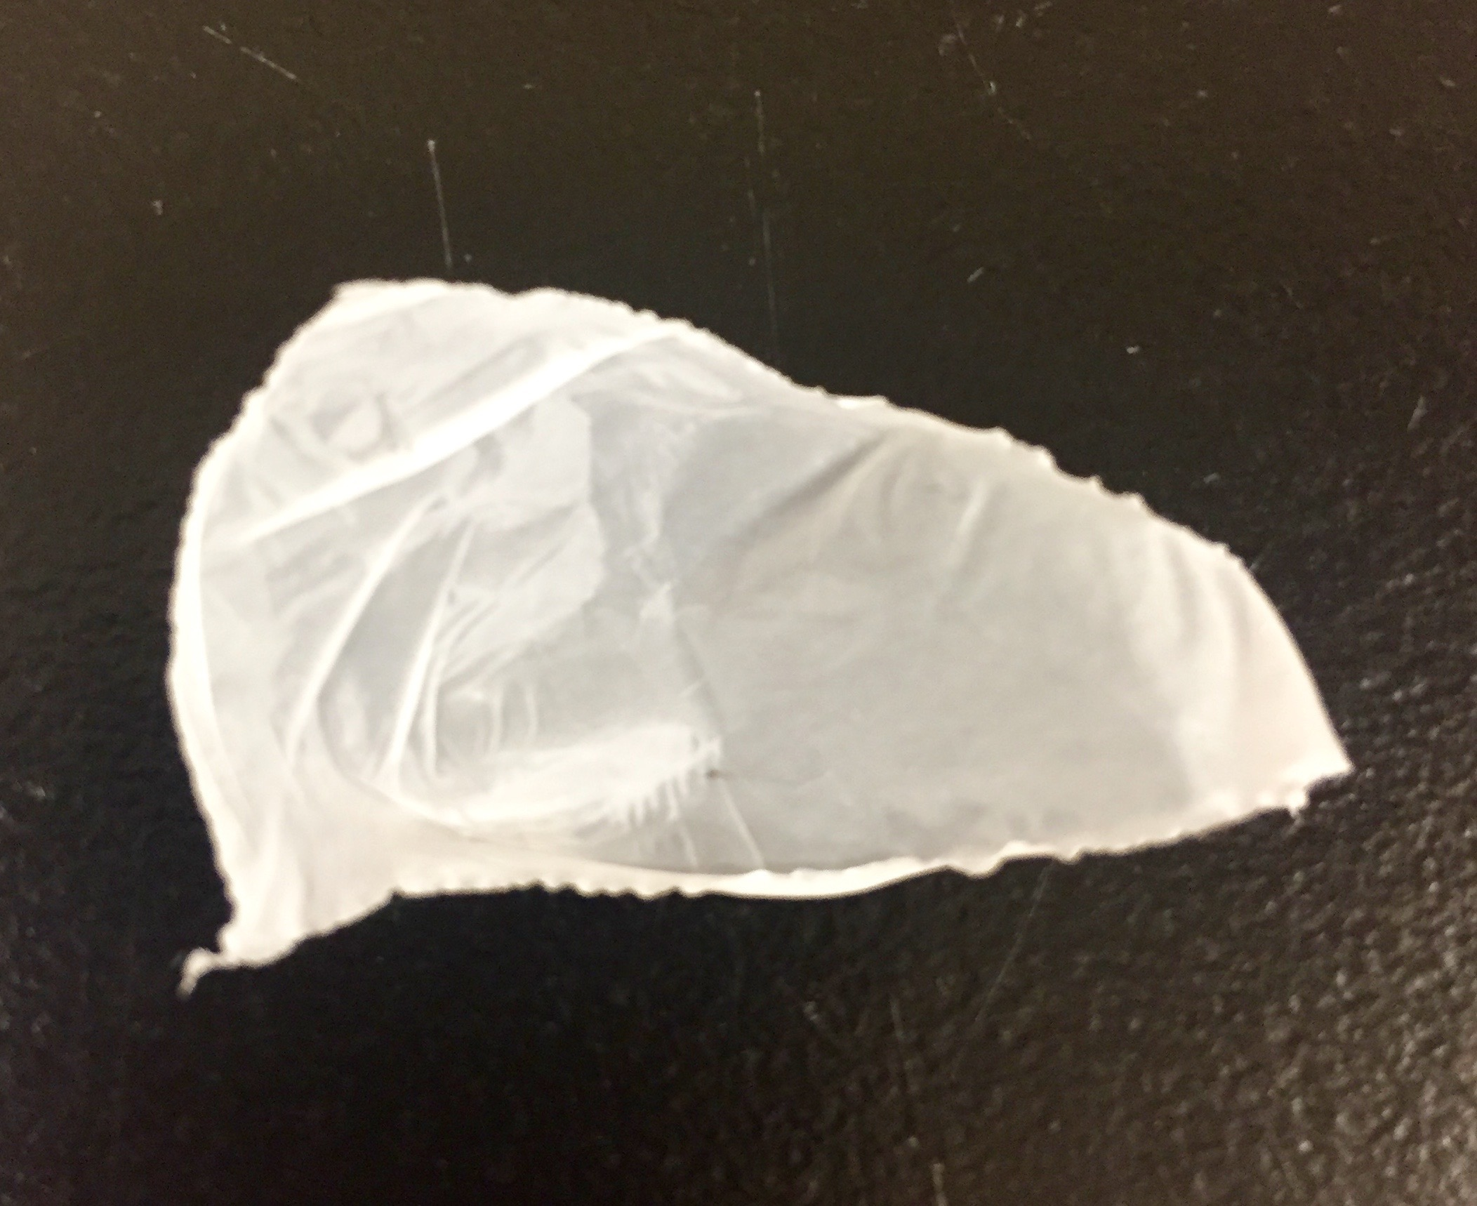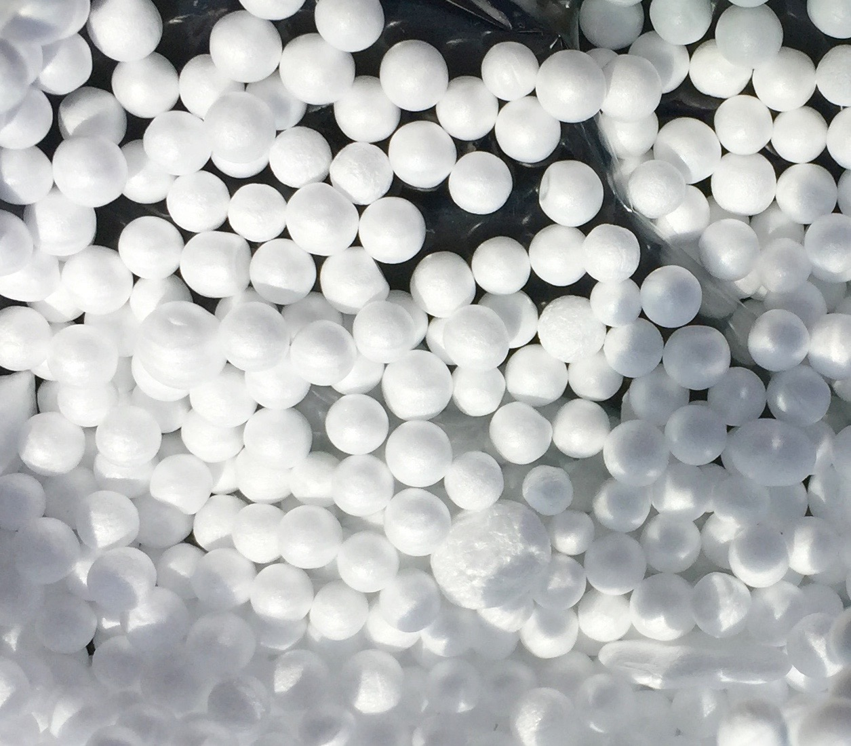

Figure 2. The five shapes of microplastics: (a) fragments (hard with jagged edges), (b) fibres (thin lines), (c) films (flimsy planes), (d) foams (sponge-like and light weight), (d) pellets (hard and spherical in shape), Photo credit: Sarah Warrack.

Figure 3. Densities of microplastics/km² calculated for each sampling date at 4 Red River sites arranged South to North in direction of flow: Emerson, Courchaine Road Bridge, Redboine boat club, and the Royal Manitoba Yacht Club, the Assiniboine River at the Forks, and the Nelson River. A triplicate sample was collected in July at the RMYC, the average and standard error calculated was 112,002 ± 29,339 microplastics/km².

Table 1. Microplastic densities in surface areas (microplastics/km²) and volume (microplastics/km³) for the 12 sites. The sites were arranged from South to North on the Red River.

Date | Site | River | Surface Area Densities of microplastics/km² | Volume Densities of microplastics/m³
06-Oct-16 | Emerson | Red | 65,626.93 | 0.70
07-Jul-16 | Courchaine | Red | 143,201.90 | 1.53
27-Jun-16 | Redboine | Red | 806,763.83 | 8.62
07-Jul-16 | Redboine | Red | 667,045.81 | 7.13
06-Oct-16 | Redboine | Red | 751,743.85 | 8.03
27-Jun-16 | RMYC | Red | 631,540.63 | 6.75
07-Jul-16 | RMYC | Red | 126142.26 | 0.94
06-Oct-16 | RMYC | Red | 808,549.79 | 8.64
27-Jun-16 | Forks | Assiniboine | 1,655,485.65 | 17.69
07-Jul-16 | Forks | Assiniboine | 157,686.44 | 1.69
06-Oct-16 | Forks | Assiniboine | 122,920.24 | 1.31
04-May-17 | Nelson | Nelson | 88,832.44 | 0.95

Figure 4. A comparison of densities of microplastics/km² in the Red River upstream and downstream of the South End Water Pollution Control Centre (SEWPCC). No upstream site was sampled in June 2016. Upstream SEWPCC sites: Emerson and Courchaine Road Bridge, and downstream SEWPCC site: Redboine Boat Club.

Figure 5. Z-scored River flux of microplastics from the Red and Assiniboine rivers associated with Z-scored WWTP flux confirmed significant relationship (Pearson Linear Correlation: R=0.96, p-value=0.00005). Redboine was sampled downstream of the South End Water Pollution Control Centre, Forks was sampled downstream of the West End Water Pollution Control Centre and RMYC was sampled downstream of North End Water Pollution Control Centre.

Figure 6. Flux of microplastics/m²/s (Z-scored) within the Red and Assiniboine Rivers as a function of season.

Figure 7. The proportion of the four types of microplastic particles ( a)fibres, b) foams, c) fragments, and d) films) found at the 6 sites. Red River sites were Emerson, Courchaine, Redboine and RMYC, the Assiniboine River site was the Forks, and the Nelson River site. The Nelson River was excluded from b), c) and d) as the site only contained fibres.

